# Lab 08:

## **Code**:

**public** **class** Acount {

**private** String name;

**private** **double** balance;

**public** Acount(String name, **double** balance)

{

**this**.name = name;

**if** (balance > 0.0)

**this**.balance = balance;

}

**public** **void** deposit(**double** depositAmount)

{

**if** (depositAmount > 0.0)

balance = balance + depositAmount;

}

**public** **double** getBalance()

{

**return** balance;

}

**public** **void** setName(String name)

{

**this**.name = name;

}

**public** String getName()

{

**return** name;

}

}

### Main class:

**import** java.util.Scanner;

**public** **class** AcountTest {

**public** **static** **void** main(String[] args) {

Acount account1 = **new** Acount("Osama2", 50.00);

Acount account2 = **new** Acount("Osama", -7.53);

System.***out***.printf("%s balance: $%.2f%n",

account1.getName(), account1.getBalance());

System.***out***.printf("%s balance: $%.2f%n%n",

account2.getName(), account2.getBalance());

Scanner input = **new** Scanner(System.***in***);

System.***out***.print("Enter deposit amount for account1: ");

**double** depositAmount = input.nextDouble();

System.***out***.printf("%nadding %.2f to account1 balance%n%n",

depositAmount);

account1.deposit(depositAmount);

System.***out***.printf("%s balance: $%.2f%n",

account1.getName(), account1.getBalance());

System.***out***.printf("%s balance: $%.2f%n%n",

account2.getName(), account2.getBalance());

System.***out***.print("Enter deposit amount for account2: ");

depositAmount = input.nextDouble();

System.***out***.printf("%nadding %.2f to account2 balance%n%n",

depositAmount);

account2.deposit(depositAmount);

System.***out***.printf("%s balance: $%.2f%n",

account1.getName(), account1.getBalance());

System.***out***.printf("%s balance: $%.2f%n%n",

account2.getName(), account2.getBalance());

}

}

## **Output**:

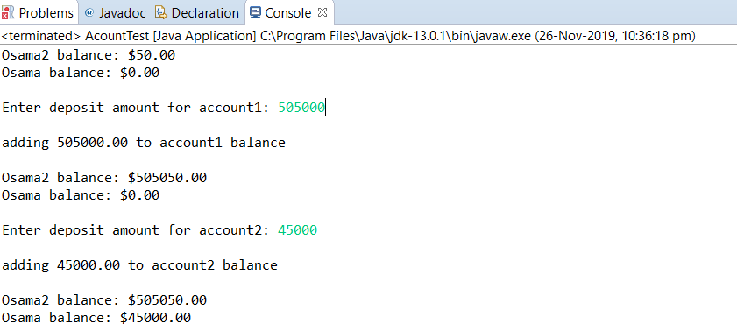

# Lab 08:

**Code**:

**public** **class** Acount {

**private** String name;

**private** **double** balance;

**public** Acount(String name, **double** balance)

{

**this**.name = name;

**if** (balance > 0.0)

**this**.balance = balance;

}

**public** **void** deposit(**double** depositAmount)

{

**if** (depositAmount > 0.0)

balance = balance + depositAmount;

}

**public** **double** getBalance()

{

**return** balance;

}

**public** **void** setName(String name)

{

**this**.name = name;

}

**public** String getName()

{

**return** name;

}

}

### Main class:

**import** java.util.Scanner;

**public** **class** AcountTest {

**public** **static** **void** main(String[] args) {

Acount account1 = **new** Acount("Naveed", 50.00);

Acount account2 = **new** Acount("Naveed2", -7.53);

System.***out***.printf("%s balance: $%.2f%n",

account1.getName(), account1.getBalance());

System.***out***.printf("%s balance: $%.2f%n%n",

account2.getName(), account2.getBalance());

Scanner input = **new** Scanner(System.***in***);

System.***out***.print("Enter deposit amount for account1:

**double** depositAmount = input.nextDouble();

System.***out***.printf("%nadding %.2f to account1 balance%n%n",

depositAmount);

account1.deposit(depositAmount);

System.***out***.printf("%s balance: $%.2f%n",

account1.getName(), account1.getBalance());

System.***out***.printf("%s balance: $%.2f%n%n",

account2.getName(), account2.getBalance());

System.***out***.print("Enter deposit amount for account2: ");

depositAmount = input.nextDouble();

System.***out***.printf("%nadding %.2f to account2 balance%n%n",

depositAmount);

account2.deposit(depositAmount);

System.***out***.printf("%s balance: $%.2f%n",

account1.getName(), account1.getBalance());

System.***out***.printf("%s balance: $%.2f%n%n",

account2.getName(), account2.getBalance());

}

}

## **Output:**

